Pockets user manual

# History

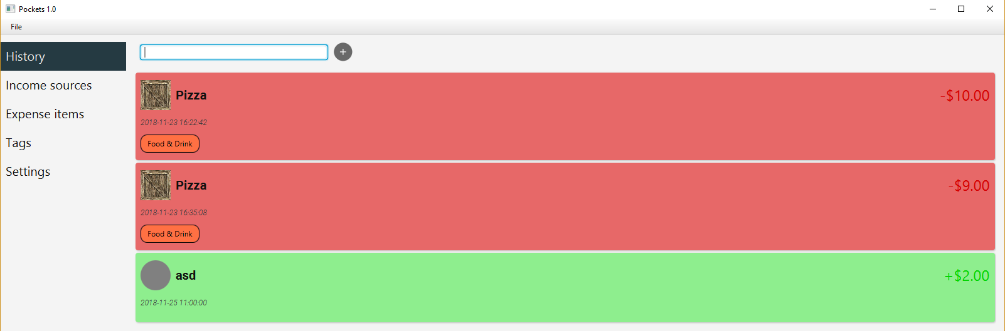

Search bar

Add button

Date of purchase/income

Name of the item

Image of the item

Tags

Expense/income in the display currency

Expense item

Income source

Income sources and expense items can be added to the history. History items can be deleted but not edited (this is by design).

## Search for history entires

You can search for the name of the item and the tags (of the item and the history entry). The search terms must be met per word. More in the search section.

## Add history entries

Selecting Income or Expense is going to change the item dropdown to contain a list of those items. You can also add a new Income or Expense item with the Add button next to it.

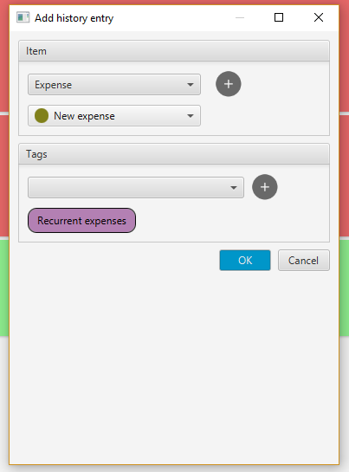

Item type  
(Income/Expense)

Item dropdown

Add new item

Tag dropdown

Add tag to the tag list

Tags

## Editing Tags

Tags can be added after selection from the dropdown, which contains non added tags. You can add tags that are present on the item itself but in that case it will only be shown once in the list.

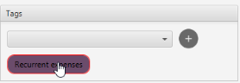To remove tags you just left click the already added tag once.

# Income sources

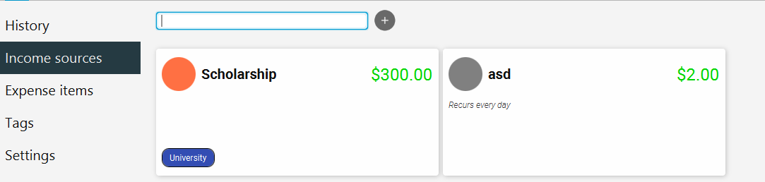

Image of the item

Add button

Search bar

Name of the item

Recurrence information

Income amount

Tags

Items are shown as cards. Each card has a limited amount of information on it  
and can be edited or deleted.

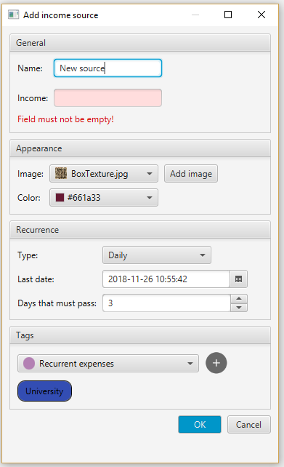

Invalid field

Error with field

## Add or edit income sources:

In item addition or deletion you can get validation errors.

The rules are:

* Item names must not be empty
* Item names must be unique
* Money field must not be empty
* Money must be in the correct format (more on that later)

## Item images:

Items can have images attached to them. If there's no image a colored circle will be used instead with the color selected.

Adding images copies them to the *user-images/* folder.

## Recurrences:

Every Expense or Income item can recur daily, weekly, monthly or never.

Recurrences have a last date and number of days/weeks/months that must pass before the next. Last date can be set up by hand or when it gets added to the history it will automatically set itself.

On the edit dialog if never is selected in the type dropdown the *Last date"* and *Days that must pass* fields will be disabled and their changes will have no effect.

Recurrent items get checked every minute whether they need to be added to the History or not. They also get checked on startup.

## Expense items

Expense items are very similar the only difference is that instead of income we call the money tag expense and it's red. The edit dialog and the card looks the same. Recurrences and item images function the same way.

# Tags

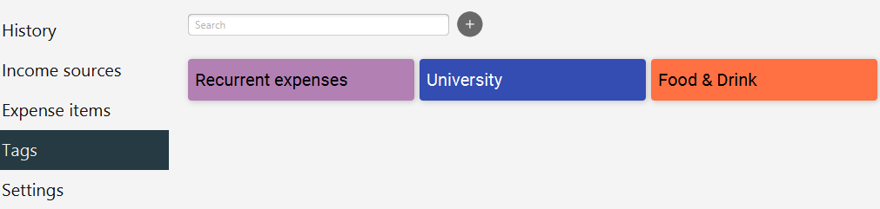

Tags can be added, edited and deleted.

## Edit dialog:

Upon adding the seach bar's content will again be pasted into the name field of the dialog.

Field rules are:

* Name cannot be empty
* Tag names must be unique

# Search

Seach works on word by word basis. Any word must at least be partially contained in the searched items name or tags (where applicable) word list.

## Item word list:

* Words in the name
* Words in the names of its tags

## History entry word list:

* Words in the name of its item
* Words in the names of its tags
* Words in the names of its item's tags

## Tag word list:

* Words in the name

# Money and currencies

## Correct formats

* Currency symbol before the number eg. $2.00
* Currency code before the number eg. USD 2.00
* Currency symbol after the number eg. 2.00$
* Currency code after the number eg. 2.00 USD

## Currency display

Display currency can be set up in settings. In this case if the currency has a symbol it will be shown in this format by default $2.00.

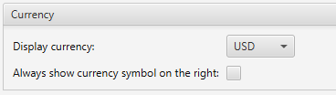If the currency symbol is usually on the left, you can still force it to the right with the *Always show currency symbol on the right* settings.

Some currency symbols will be always on the right side of the number such as 200Ft.

If the symbol is not known the 3 letter currency code will be shown on the right eg. 2.00 USD.

The money number will always be rounded to 2 decimal places according to standard rounding rules. This even happens in currencies where it makes no sense or rounding rules are not the same (such as HUF).

## Supported currencies

In principle all currencies and common symbols should be working.  
But only USD ($), HUF (Ft), GBP (£), EUR (€) are supported.

# Date time format

Date time format can also be set up in the settings, this date time format will be used in the date time fields and will be the display format.

# Currency conversion API:

Although we ship the app with static currency conversion data, an API can still be used to get up to date currency exchange rates. The API used in the application is OpenExchangeRates.

The settings allow you to:

* Disable the API completely
* Use environment variable *OpenExchangeRatesApiKey* to get the API key
* Type in your API key and let *app-settings.json* handle the saving (not necessarily recommended)

You can register your own app on the website <https://openexchangerates.org/> to get an API key.

# Common errors:

## API unavailable and no known conversion rates exist

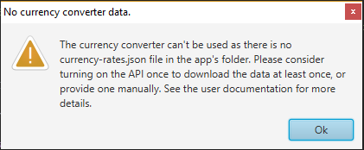

This actually a warning as it's not fatal to the operation of them application. The API is the only way for the program to know the currency rates. The program ships with the currency rates but if you delete it you may be welcomed by this warning.

## API key not found

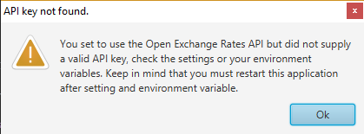

API key not found, you didn't set it up correctly in the settings. Refer to the section on that above.

## API error

There's actually no alert for this as if your internet goes out it could be annoying. If there's currency rates saved then you will never see this error. Just keep this in mind.

## Error loading files

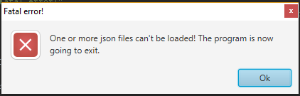

If you see this fatal error, it means the program cannot run in any meaningful way as the files are inacessible or corrupted.

Unfortunately error recovery is not supported yet, but this most likely means the program can't access the files anyway.

## Error saving files

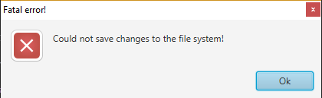

If you see this fatal error, all bets are of and your changes won't be saved. Unfortunately error recovery is again not an option yet. Your files are probably right but they could also become corrupted.

**Common reasons:**

* Not enough space on the hard drive
* No access to the files
* You are currently editing the files (yeah don't do that)

## Error adding images

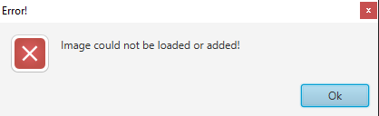

Simply put again some sort of file reading or writing issue. Although in this case the error recovery is easier and can be done manually as it's basically just a file copy from the place you have your image to the *user-images/* folder next to the application.